DOI: 10.24136/tren.202X.0XX (Filled in by the editorial staff)
Information for the authors preparing an article to be published
in transEngin quarterly
(The article title should contain at least one keyword!)
Jan Kowalski ^{1,*}, Second Author ², Third Author ³
¹ Casimir Pulaski Radom University, Faculty of Transport, Electrical Engineering and Computer Science, Malczewskiego 29,
26-600 Radom, Poland, e-mail: author@urad.edu.pl
² University, Research and Development Unit, Company, ... , e-mail: author@mailserver.com (Affiliation in English)
³ University, Research and Development Unit, Company, ... , e-mail: author@mailserver.com (Affiliation in English)
* Corresponding author
Jan Kowalski https://orcid.org/0000-000K-KKKK-KKKK, Second Author https://orcid.org/0000-000S-SSSS-SSSS,
Third Author https://orcid.org/0000-000T-TTTT-TTTT
(Please enter the ORCID number of each Author)
Reviewed positively: xx xxxxxx 20xx (Filled in by the editorial staff)
Information about quoting an article:
Kowalski J., Autor S., Autor T. (20XX). Title of the article submitted for publication in the transEngin quarterly. Journal of civil engineering and transport. xx(x), xx-xx, ISSN 2658-1698, e-ISSN 2658-2120,
DOI: 10.24136/tren.202X.0XX (Filled in by the editorial staff)

Abstract − Above instructions contain basic guidelines that help authors to prepare an article for publication in the Journal of civil engineering and transport (transEngin). Abstract containing maximum 200 words should be intelligible and summarize basic issues in the content of an article (background, objectives, methodology, results, conclusions) and include key words. An author should not use more than 200 words in an abstract, because it will be included to an on-line version of the journal and sent for the purposes of subscripting to international databases. The signs, such as special symbols, letters of Greek alphabet, styles of subscript and superscript, should not be included in content of an abstract. Abstract should not include footnotes. Before submitting an article, please acquaint yourself with the guidelines concerning publishing procedure on the journal’s website: www.transengin.uniwersytetradom.pl.
Key words − maximum five key words or phrases in alphabetical order, separated by commas
JEL Classification − maximum five codes, separated by commas (https://www.aeaweb.org/econlit/jelCodes.php?view=jel)

Introduction
The authors are asked to send articles within the scope of the subjects of this journal. Text of an article should be written in English, formatted using styles defined in this document in a final form, ready for publication. Please do not use empty lines to make spaces. Please do not edit headings and footers. They are edited and formatted by the journal’s editorial staff. All subsequent versions should be sent using the same identifier of an article.
Please submit your article in .docx format (Microsoft Word 2016 or later) to transengin@urad.edu.pl. An article must have even number of pages: minimum of 8 pages or more. We do not publish short articles.
We reserve the right to make minor editorial corrections in the text of an article.
Information about the article, which was created as part of a research project should be placed in the footnote on the first page. If this is not the case, please remove the entry from the footnotes.

Copyright
The following documents must be attached while submitting an article: article application, publishing agreement. They can be downloaded from the website. All authors are obliged to sign above documents and send them to: transengin@urad.edu.pl.

Sheet and text format
We recommend to use this template to format an article. It has properly defined sheet dimensions, heading and footers etc. and styles. Among other, style defines type and font size and spaces between lines. Please do not change neither font size or spaces between lines to have more text on the limited number of pages. To underline text, please use italics instead of underlining. While editing text of an article, please pay attention to correct writing of indexes and markings. For example, frequent error is writing down letter „o” instead of number „0”.
The author's first and last name, affiliation, full address and email must be given under the title. In the event that there are many authors, please give affiliation and full address of every author and e-mail addresses. Enter the ORCID number of each author below.
- Click here to display Style window – making it easier to select and apply styles of transEngin templates.

To adjust style to paragraph, click any place of paragraph text, then click appropriate style in Style window.

Tables and illustrations

Illustrations
In order to insert an illustration, put a cursor in an inserting point and use the option Insert | Picture | From a file or copy an image to Windows clipboard, and then click an image and select in sequence: Formatting | Layout | Text Wrapping | Wrapping style „In line with text”.
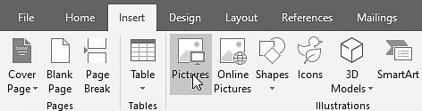
Fig. 1. Inserting an image (illustration)
An illustration should be described in a caption of an illustration in short Fig. 1. and not in the content of an article Figure 1 or (Fig. 1).
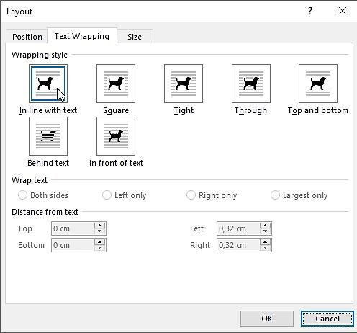
Fig. 2. Editing parameters of inserted image (illustration)
The illustrations: figures, graphics, charts etc., (non-editable in Microsoft WORD – graphic files such as JPG, PNG, BMP) inserted centred in the content of an article should be legible and clear of the resolution of minimum 300dpi. Please do not use fonts of the size smaller than 8.
Coloured illustrations are acceptable, but please make sure they are legible in the print of grayscale.
Large illustrations should be inserted at the end of a given page where they are referred to in the text or, as a last resort, at the beginning of the next page.

Tables
The tables must include description at the top, aligned to the left side of a column. Please do not shorten references to the tables, correct version is Table 1.

Table 1. Recommended Styles
Item | Style
Title of an article | Title
Author’s Name and Surname | Authors
Author’s Address | Affiliation
Abstract | Abstract
Key words | Index Terms
Introduction | Introduction
Titles of chapters | Heading 1
Titles of subchapters | Heading 2
Text | Text
Footnote | Footnote text
Enumeration | Numbered list
Description of a Figure | Figure Caption
Table Title | Table Title
Text in Table | Text in Table
Equation | Equation
Bibliography Chapter’s Title | References Head
References | References

Please leave one empty paragraph before description of a table, and after that.

Mathematical formulas
To create and edit mathematical formulas in article, use Microsoft Equation Editor or MathType (www.wiris.com/mathtype) (Insert | Object | Create new | Equation Microsoft or MathType | Inline).
(1)
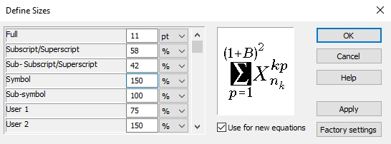
Style of fonts and symbols in equations and references to them in the text of the article: Regular. Every equation should take up one line. Subsequent numbers should be marked in brackets. All equations should be numbered (numbers should be aligned to right) and quoted (1) in the text.

Quotations
Standard APA with endnotes:
References – descriptions in accordance with order of quoting,
References in the text – footnotes numbered one by one in this place of text, in which they were quoted for the first time.
The quotations should be numbered one by one in the square brackets [1]. To quote many references, use form of writing [2], [4-5], [7, 9], instead of [2], [4], [5], [7], [9]. You must not use automatic endnotes in Microsoft Word, instead please write down the titles to the list at the end of an article using Style „References”.
Provide full names and surnames of all authors, do not use "et al.", unless there are five authors or more.
References should be given with very precise data to help the reader finding them, including volume and page numbers.
Auto quotations in the publication are unacceptable. Moreover, Authors are requested to reduce citations of publications in other languages than English to an absolute minimum. The publisher reserves the right to demand, at an any stage of the editorial process, the removal of quotations, which contradict the stated publishing philosophy of transEngin, as a necessary condition for acceptance.
DOI numbers for press articles, books, conference papers, etc. should be given if they are assigned to them. Each DOI number should contain a hyperlink (see positions [4-7] in the References). The articles that have not been published should be quoted only when they have DOI number assigned and should be defined as "to be published" [7]. The articles that were submitted for publication or accepted for publication, but were not assigned yet to a specific issue (volume) and do not have a DOI number, should not be quoted.

Conclusions
Summary should include information about importance of an article and emphasize scientific contribution and differences towards other articles on a given subject. The expressions from an abstract should not be repeated in the summary.
The conclusions is a text chapter – please do not use equations, charts, illustrations and quotations.
Make sure that layout of the text of the whole article complies with recommendations on formatting described here!

Annex A
If the content of an article requires annexes to be added, please describe them with letters A, B, C etc. and place them before chapter (section) „Bibliography”.
Before the bibliography, the title and abstract of the article and the keywords should be written in Polish, following the example below.

Abbreviations
1. CI engine - Compression Ignition engine;
2. TDC - Top Dead Center of the piston;
3. VCR - Variable Compression Ratio.
Attention! Authors from Poland
The References should be preceded by the title and abstract of the article in Polish and the key words according to the example below.

Title of the Article (in Polish)
Abstract (in Polish), containing maximum 200 words should be intelligible and summarize basic issues in the content of an article (background, objectives, methodology, results, conclusions) and include key words. An author should not use more than 200 words in an abstract, because it will be included to an on-line version of the journal and sent for the purposes of subscripting to international databases. The signs, such as special symbols, letters of Greek alphabet, styles of subscript and superscript, should not be included in content of an abstract. Abstract should not include footnotes.
Key words (in Polish): maximum five key words or phrases in alphabetical order, separated by commas.

References
- Please use only the Latin alphabet in the References!
- APA bibliographic style.
- Heywood J. (2019) Internal Combustion Engine Fundamentals. 2nd Edition. McGraw-Hill Education, ISBN 9781260116106.
- Zbiciak A., Kraśkiewicz C., Lipko C., Oleksiewicz W. (2016). Viscoelastic dynamic models of resilient elements used in railway tracks. IPICSE-2016, MATEC Web of Conferences, 86,
https://doi.org/10.1051/matecconf/20168601015.
- Shen H, Wang H, Hu J, Yao ZQ. (2015). The Process Planning in Laser Thermal Adjustment of Three Cut-Outs Actuators. International Journal of Precision Engineering and Manufacturing, 16(12), 2475-248.
https://doi.org/10.1007/s12541-015-0318-4.
- Zaleski K, Skoczylas A. (2014). Studies on selected properties of surface layer of C45 steel objects after laser cutting and milling. Advances in Science and Technology Research Journal (ASTRJ), 8(23), 26–32.
https://doi.org/10.12913/22998624.1120311.
- Wolter G. (2017). Safety in railway traffic (Periodical style - Accepted for publication, but the DOI number has been assigned). IEEE Transactions on Antennas and Propagation, to be published,
https://doi.org/10.4312/ieee.1957.7254.
- Petring D. (2005). Laser cutting welding with one tool. [In:] The Fabricator®.
- www.cepik.gov.pl/statystyki (access date: 21/10/2019).
- You must give 15÷20 literature references from major publishing houses and journals.

Copyright by transEngin
The above document may be used only by authors of publications applying to the transEngin quarterly.
All rights reserved. No part of this Preparation of the Article may be modified, reproduced or transmitted in any form or by any means, electronic or mechanical, including photocopying, recording, or by any information storage and retrieval system, without permission in writing from publisher.

The article was created as part of the project POIG.01.03.01-0XX/XX NCBiR 20XX. „Xxxx xxxxx xxxxxxx xxxxxxx xxxxx x xxxxx xxxx xxxxxxx xxxxxx”

